**MIS 273 Assignment 8 for week 9: Some Tasks on Managing and Monitoring the Server**

**Before you do parts 1, 2 and 3 of this lab be sure that you have read Chapter 18 on Maintaining Server Installations. Before doing parts 4 and 5, be sure to read Chapter 19 on Monitoring. Login as administrator to your domain controller where Active Directory is installed for all tasks below.**

**Part 1: Managing Windows Update Settings with Group Policy**

In this section you will configure the Windows Update Settings using the Group Policy Editor.

Perform steps 1-7 from slides 9 and 10 of 70-740_Lesson 18.pptx PowerPoint slides.

For step 3 to get to the Group Policy Editor in the Group Policy Management Windows choose Edit from the Action menu.

For step 5 double-click Configure Automatic Updates.

For step 6 use the drop down menu to select from the options.

To show you’ve done this task, take a screen shot of the Configure Automatic Updates window after selecting one of the options in step 6.

Paste the screen shot here:

There is no edit button that I can find.

**Part 2: Install an Upstream WSUS Server**

Perform steps 1-19 from slides 16 and 20 of 70-740_Lesson 18.pptx PowerPoint slides. After selecting Next on the Specify Proxy Server page, to show you’ve done this task, take a screen shot of the Connect to Upstream Server page and paste it below. This is far as you need to go through this task. Since we don’t have other servers installed in our domain to use as downstream WSUS servers, there’s no need to synchronize with Microsoft about updates.

Paste the screen shot here:

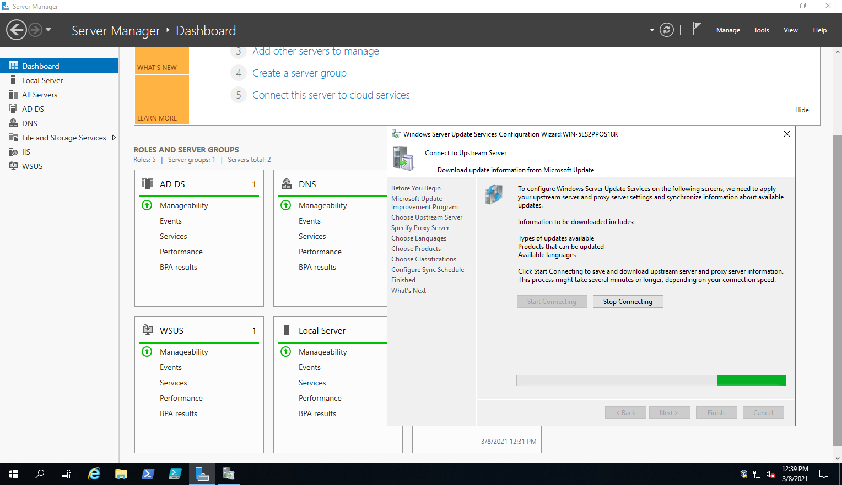

**Part 3: Windows Server Backup**

Perform steps 1-8 from slide 59 of 70-740_Lesson 18.pptx PowerPoint slides to install the Windows Server Backup Feature.

Perform steps1-6 from slide 64 of 70-740_Lesson 18.pptx PowerPoint slides to configure a manual backup. In step 3 you may have to select Local Backup to see the Backup Once option in the Actions panel. To show you’ve done this task, paste a screen shot of the Select Items window after selecting the E: drive or some other volume or disk below. *Note*: There is no need to follow through on the backup. You can cancel the process once you’ve done the screen shot.

Paste the screen shot here:

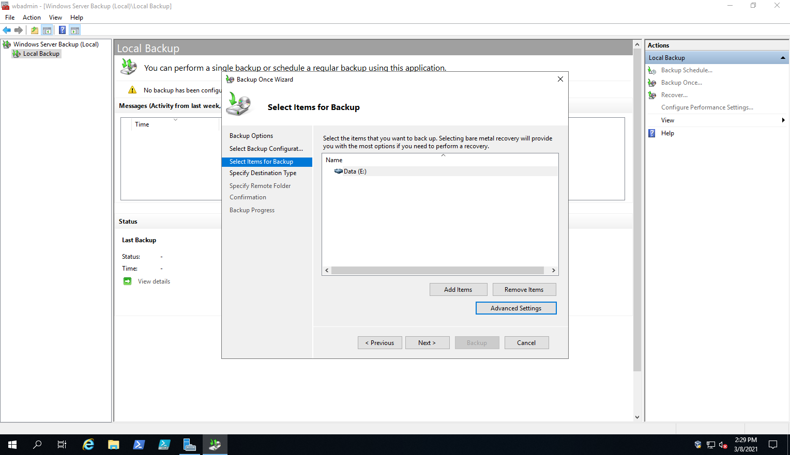

Now perform steps1-6 from slide 66 of 70-740_Lesson 18.pptx PowerPoint slides to configure a scheduled backup. In step 3 you may have to select Local Backup to see the Backup Schedule option in the Actions Panel. After performing step 6, to show you’ve done this task, paste a screen shot of the Specify Remote Shared Folder window below. *Note*: There is no need to follow through on the backup. You can cancel the process once you’ve done the screen shot.

Paste the screen shot here:

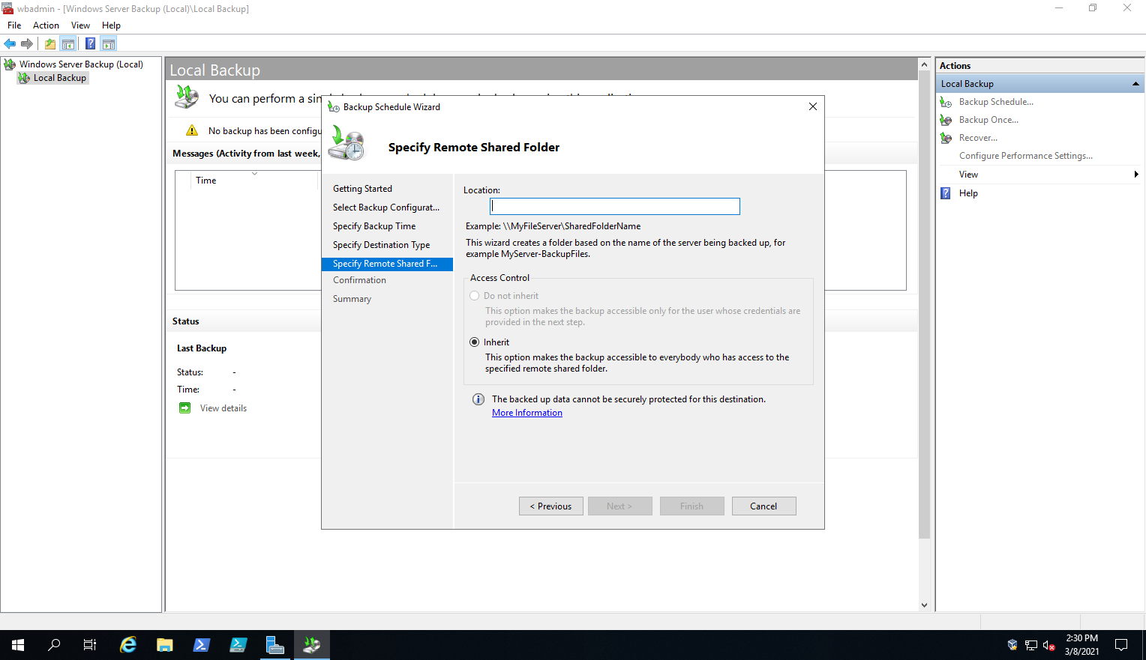

**Part 4: Using Resource Monitor**

Perform steps1-3 from slide 10 of 70-740_Lesson 19.pptx PowerPoint slides. To show you’ve done this task, paste a screen shot of the Resource Monitor window with the CPU tab selected below.

Paste the screen shot here:

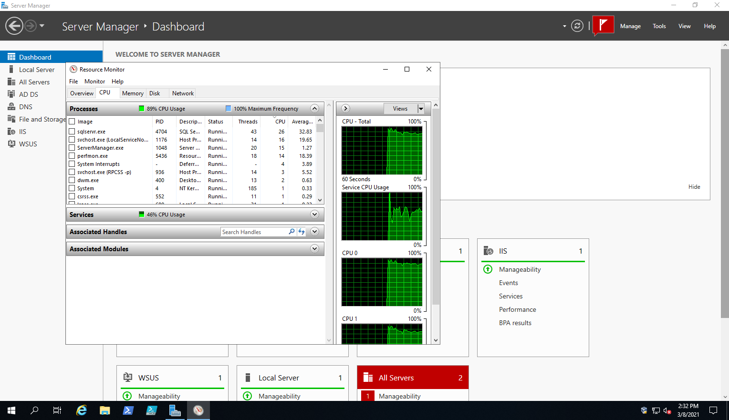

**Part 5: Using Event Viewer**

Perform steps1-11 from slides 37-38 of 70-740_Lesson 19.pptx PowerPoint slides. To show you’ve done this task, paste a screen shot of the Event Viewer with the Group Policy/Operational node selected below.

Paste the screen shot here:

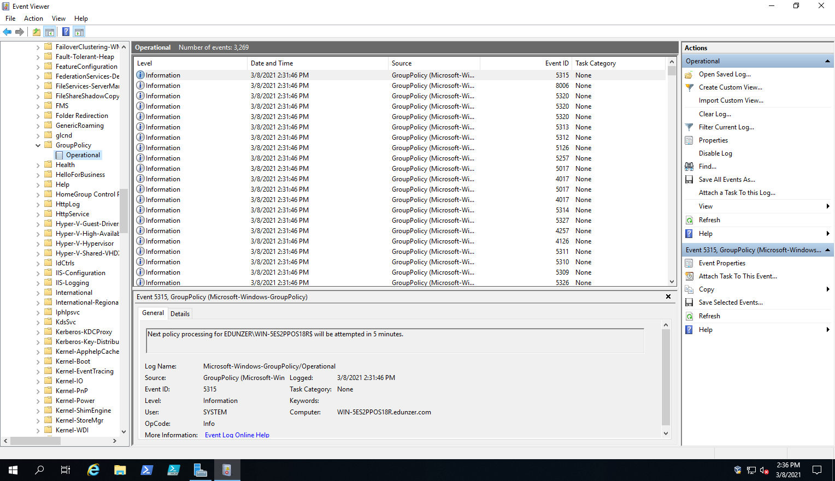

**Submit and upload your completed document with screen shots to Canvas in the assignment area for this lab.**